**Project Proposal**

Name: Ammad Jamil

Section: BSIT-5A

Arid: 2020 _arid_0184

Project Name: Inventory Management System

Date: 26/3/22

Submitted to: Sir Azhar Jamil

**Introduction to Inventory Management System**

The project Inventory Management System is a complete desktop based application designed on Net technology using Visual Studio Software. The main aim of the project is to develop Inventory Management System Model software in which all the information regarding the stock of the organization will be presented.

It is an intranet-based desktop application which has admin component to manage the inventory and maintenance of the inventory system. This desktop application is based on the management of stock of an organization. The application contains general organization profile, sales details, Purchase details and the remaining stock that are presented in the organization.

There is a provision of updating the inventory also. This application also provides the remaining balance of the stock as well as the details of the balance of transaction.

Each new stock is created and entitled with the named and the entry date of that stock and it can also be updating any time when required as per the transaction or the sales is returned in case. Here the login page is created in order to protect the management of the stock of organization in order to prevent it from the threads and misuse of the inventory.

**Features of Project**

This application is used to show the stock remaining and details about the sales and purchase. It gives the details about the stock on daily based and weekly based. The details components are described below:

**Login page:**

As application starts the login page appears. Admin login is determined by the username and password that has all the authority to add, update and delete the stock of the organization as per the requirement.

**Sales details:**

It show the details about the sales and the remaining stock of sales. It also show the details about the sales in return.

**Purchase details:**

It shows the details about the purchase made by the organization along with the price and dates

**Structured Query Language (SQL)**

The structured Query language (SQL) is the set of instructions used to interact with a relational database. In fact, SQL is the only language the most database actually understand. Whenever you interact with such a database, the software translates your commands into SQL statement that the database knows how to interpret. SQL has three major Components:

Data Manipulation Language (DML)

Data Definition Language (DDL)

Data Control Language (DCL

**The Application allows to:**

* Create, delete and update users
* Create, delete and update products.
* Create, delete and update products categories.
* Create, delete and update customers
* Add Orders When a user orders a product, the product quantity is updated
* The Order can be printed
* A dashboard presents the Number of orders made by a particular customer, The total amount of the orders by the given customer and the date of the last order.

**Use case Diagram**

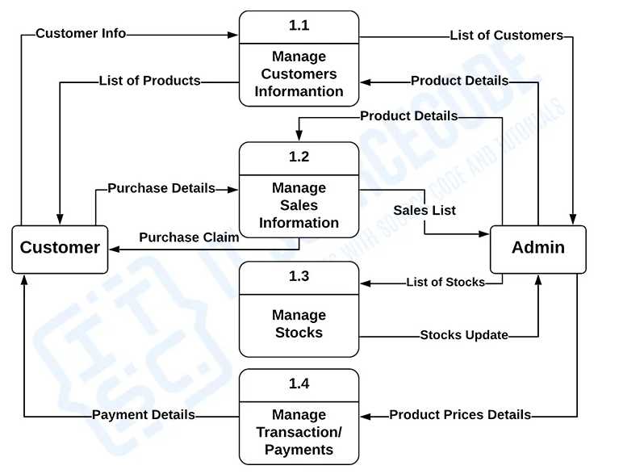

These procedures require information such as record of customers, orders, reservations, deliveries and payment from which served as the bases for sellers and admin to manage the inventory management system. This type of data is represented by a data store.  
  
With being knowledgeable about the DFD level 1 of the Inventory Management System, you will know then its broaden context terms.  
  
In addition to that, this may also serve as your reference on how the inputs or data fed on the system. Then you will be also informed about the outputs that the system gives.

These processes shown in the DFD were all based on the concept of Inventory Management System.